# Radiology eReferrals

## Communication to general practice

Some brief suggestions regarding coms to practices.

***Radiology eReferrals***

*From 1st July 2015 all referrals for publically funded radiology should be sent on a BPAC eReferral. Breast imaging requests will be proposed by WBOPPHO or EBPHA depending on which organisation your practice is affiliated to. All other radiology will continue to go straight to the BOPDHB radiology department.*

*ACC and other private radiology requests such as pregnancy imaging and immigration medicals should continue to be sent directly to private providers using established mechanisms.*

*To make a radiology eReferral you will need to follow these steps.*

1. *Enter radiology in the eReferral search box*

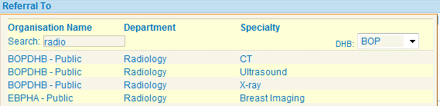

1. *Select the appropriate modality i.e CT / Ultrasound / X-ray / Breast imaging*
2. *Select the appropriate anatomical site. For example for CT*



1. *Click on the modality tab*



1. *Complete the indication for the investigation*

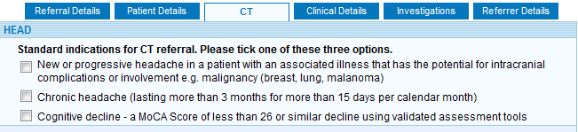

1. *Complete any other information requested – further boxes may open depending on which indication is ticked.*
2. *Complete the rest of the referral as you do other eReferrals. If the standard indications have been followed no additional clinical information is required*

***Note:***

* *The standard indications have been taken from the Midlands Radiology Community Minimum Access Criteria. A link to the document can be found on Bay Navigator and the first page of the referral form.*
* *It is possible to request imaging of more than one anatomical site on one form as long as it is by the same modality.*
* *Breast imaging allows the simultaneous request of mammogram and ultrasound. Different investigation modalities for other body parts will need to be sent on different forms.*
* *If requesting an investigation outside of those criteria, the referrer should phone the radiology department at either Tauranga or Whakatane Hospitals to speak to the on-call radiologist for advice. If approved the radiologists name and the clinical details should be entered into the referral.*
* *Referrers may be audited on their use of radiology services. Improved access to a number of investigations is now available as long as clinical criteria are met. Please use this access appropriately.*
* *There is no long direct access to fluoroscopy for GPs. A review of the evidence has suggested fluoroscopy has very few indications. Access is now via gastroenterology or speech and language therapy. Patients should be referred to those specialties for assessment.*
* *There is no option to copy results to another clinician. This is a deliberate omission. Recent discussions concerning risk associated with uncertainty regarding responsibility for results has suggested that copying results to other clinicians is not appropriate. If a clinician believes a colleague need be made aware of a result, that result should be forwarded to that clinician along with the clinical context and any associated actions that are expected.*